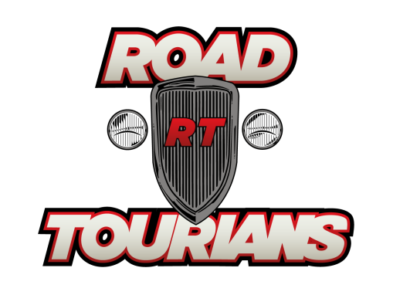

**Speedway Motors Museum / Lincoln, NE**

**To**

**Bonneville Speed Weeks / Wendover, NV**

**Classic Bus Tour July 29, 2015 to August 6, 2025**

**REGISTRATION FORM**

***Registrations are limited to 50 people based on double occupancy***

NAME: ___________________________________________________________________

Cell phone # : ______________________________________________________________

EMAIL : ___________________________________________________________________

ADDRESS: _________________________________________________________________

City: _________________________________ State: ___________ Zip: _______________

***REMEMBER THAT THIS TOUR IS LIMITED TO 50 people based on DOUBLE OCCUPANCY***

**Please print and fill out the above registration form. You will also need to complete the Payment Information and the Participant Release Forms.**

***Send the three signed forms with your non-refundable $500 deposit to:***

**Classic Road Tours, LLC**

**7001 Silica Road**

**Youngstown, Ohio 44515**

***If you have any questions or concerns please contact****:*

Jerry Dixey

Classic Road Tours Director

[**jerry@roadtourians.com**](mailto:jerry@roadtourians.com) or **330-506-9169**